Peggy Guggenheim

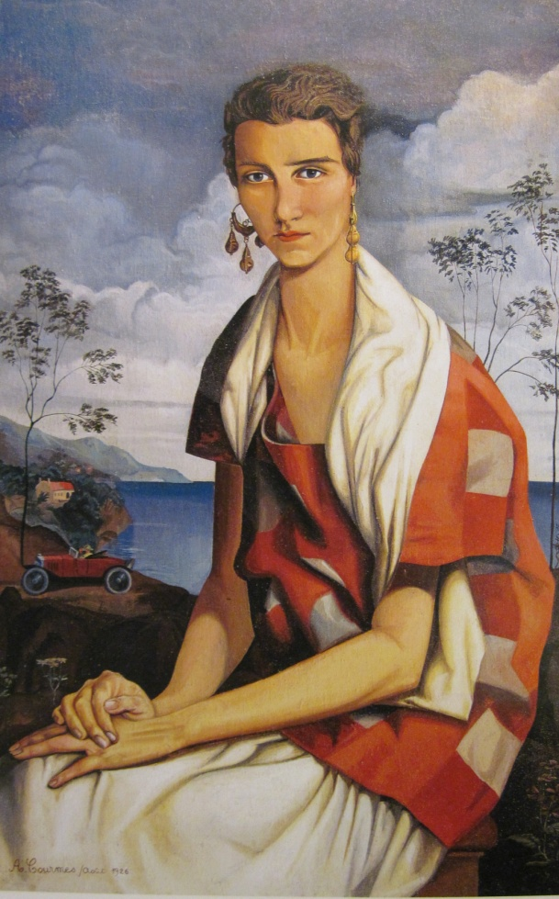In any history of the migrations and transformations of modernism, Peggy Guggenheim (1898-1979) deserves a privileged place. She shares with Marcel Duchamp, a close friend and her first guide to modern art, the distinctive merit of introducing **surrealism** to the New York School artists. Though it formed her taste, surrealism was by no means the only force behind her acquisitions. Her collection comprises masterpieces by a variety of European artists she enthusiastically promoted—from Kandinsky to Klee, from De Chirico to Severini, from Giacometti to Brancusi—and of American artists she supported through thick and thin, most notably Jackson Pollock. It is Pollock’s wife, painter **Lee Krasner**, who perhaps helps document Peggy Guggenheim’s role with some degree of accuracy when she describes Art of This Century, the New York gallery at 30 West 57th , as “the foundation”: “it’s where it all started to happen. There was nowhere else in New York one could expect an open-minded reaction. Peggy was invaluable in founding and creating what she did.”

Her career began in London in 1937 with the opening of her first gallery, the Guggenheim jeune. For fifteen years before then she had apprenticed herself to the Parisian bohemian circles and had met Marcel Duchamp. His **ready-mades** had introduced her to the surrealist technique of activating unconscious thoughts through ordinary objects which, taking on irrational, perturbing, or erotic meanings, were displaced and metamorphosed. But it was in London that her of surrealist iconography was further refined under the teachings of Herbert Read, one of the organizers of the first **British exhibition on Surrealism** (1936), and her friendship with Humphrey Jennings, who introduced her to André Breton. She felt the unbearable affront that the growing movement represented for the art establishment and was led to favor the work of Jean Arp, Henry Moore e Paul Delvaux. Guggenheim Jeune was a critical success though not a financial one.

In October 1942 she opened her second gallery in New York, Art of This Century. The paintings were detached from the walls and suspended with ropes reaching from the ceiling to the floor so that they might be experienced as material objects within the viewer’s space. The surrealist room, lined with striated wood, seemed a tunnel with a low and fluctuating ceiling. This time Howard Putzel (1898-1945), a writer and art dealer, replaced Duchamp and Read in the role of trusted advisor. He made her aware of little known American artists active in New York. She soon gave shows to Pollock, Baziotes, Motherwell, Hare, Rothko, and many others.

From 1948 her collection was housed in Palazzo Vanier dei Leoni in Venice. She finally realized the dream she shared with other internationally renowned collectors before her like the Fricks and the Steins—that of a house-museum. Like **Sarah Stein** she was consumed by art because it was an affordable outlet for their intellectual ambition. This ambition has not always been generously assessed by her compatriots. Writing for *The Nation* (1945) **Clement Greenberg** praised her as an intuitive force of nature who lacked a “sure or judicious” taste. Similarly, to aspiring artists like Nell Blain in love with Arp and Mondrain who visited Art of this Century regularly, its owner could remain a somewhat unreadable figure-- an eccentric businesswoman in a pink knit dress without stockings or underwear “looking like a sexy witch.”

Barbero, Massimo L. *Peggy Guggenheim e la Nuova Pittura Americana*. Firenze: Giunti, 2008.

Barbero, Massimo L.,, ed*. Peggy Guggenheim e l’Immaginario Surreale*. Firenze: Giunti, 2007.

Berengo-Gardin, Gianni. *Peggy Guggenheim, La Casa, Gli Amici, Venezia*. Firenze: Giunti, 2009.

Calas, Nicola and Calas, Elena. *The Peggy Guggenheim Collection of Modern Art*. Foreword Sandro Rumney. New York: Rizzoli 2001.

Dortch. Virgina M., ed. Peggy *Guggenheim and Her Friends*. Milan: Berenice, 1994.

Guggenheim, Peggy. *Out of This Century: Confessions of an Art Addict*. Foreword Gore Vidal. Intro. Alfred H. Barr. New York: Universe Books, c. 1979.

*Masterpieces from the Peggy Guggenheim Collection*. New York: The Solomon R. Guggenheim foundation, 1993.

Vail, Karole P. B. *Peggy Guggenheim: A Celebration*. New York: Guggenheim Museum, 1999.

Image: Alfred Courmes, *Portrait of Peggy Guggenheim*, 1926.

Oil on canvas, 100 x 65 cm. Musée National de la Coopération

Franco-Américaine, Château de Blérancourt,

Gift of the Amis du Musée, 1985 [MM]